PIZZA SALES SQL QUERIES

**A.KPI’S**

**Total Revenue:**

SELECT SUM (total_price) AS Total_Revenue FROM pizza_sales_csv;

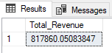

**Average Order Value:**

SELECT (SUM (total_price) / COUNT(DISTINCT order_id)) AS Avg_order_Value FROM pizza_sales_csv;

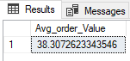

**Total Pizza’s sold:**

SELECT COUNT (DISTINCT order_id) AS Total_Orders FROM pizza_sales_csv;

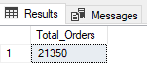

**Average Pizza’s per order:**

SELECT CAST (CAST(SUM(quantity) AS DECIMAL(10,2)) /

CAST (COUNT(DISTINCT order_id) AS DECIMAL(10,2)) AS DECIMAL(10,2))

AS Avg_Pizzas_per_order FROM pizza_sales_csv;

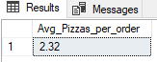

**B. Daily Trend for total orders:**

SELECT DATENAME (DW, order_date) AS order_day, COUNT (DISTINCT order_id) AS total_orders FROM pizza_sales_csv

GROUP BY DATENAME (DW, order_date);

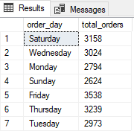

**C. Hourly trend for orders:**

SELECT DATEPART (HOUR, order_time) as order_hours, COUNT(DISTINCT order_id) as total_orders from pizza_sales_csv

group by DATEPART(HOUR, order_time)

order by DATEPART(HOUR, order_time);

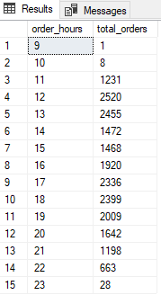

**D. Percentage of sales by pizza category:**

SELECT pizza_category, CAST (SUM(total_price) AS DECIMAL(10,2)) as total_revenue,

CAST (SUM(total_price) * 100 / (SELECT SUM(total_price) from pizza_sales) AS DECIMAL(10,2)) AS Percentage FROM pizza_sales_csv

GROUP BY pizza_category;

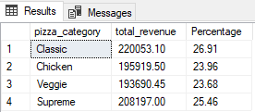

**E. Percentage of pizza sales by size:**

SELECT pizza_size, CAST (SUM(total_price) AS DECIMAL(10,2)) as total_revenue,

CAST (SUM(total_price) * 100 / (SELECT SUM(total_price) from pizza_sales_csv) AS DECIMAL(10,2)) AS Percentage FROM pizza_sales_csv

GROUP BY pizza_size

ORDER BY pizza_size;

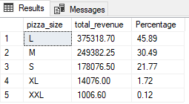

**F.Total pizza sold by pizza category:**

SELECT pizza_category, SUM (quantity) as Total_Quantity_Sold FROM pizza_sales_csv

GROUP BY pizza_category

ORDER BY Total_Quantity_Sold DESC;

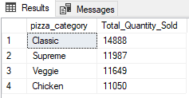

**G.Top 5 best sellers by total pizza’s sold:**

SELECT Top 5 pizza_name, SUM (quantity) AS Total_Pizza_Sold FROM pizza_sales_csv

GROUP BY pizza_name

ORDER BY Total_Pizza_Sold DESC

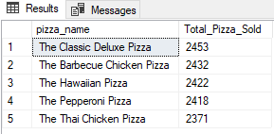

**H.Bottom 5 best sellers by total pizza’s sold:**

SELECT TOP 5 pizza_name, SUM (quantity) AS Total_Pizza_Sold FROM pizza_sales_csv

GROUP BY pizza_name

ORDER BY Total_Pizza_Sold ASC;

